1. **Getting Started**

**Running PostgreSQL in Docker-Compose**

Screen #1 – cd util, docker-compose up

**Compiling the Code**

Screen #2 – Job failed because of front-end compile errors

Screen #3 – Job failed because of back-end compile errors

**Section 2 – Utilize Deployment Strategies to Design and Build CI/CD Pipelines that Support Continuous Deliver Process**

1. **Build Phase**

**Test Phase**

Screen #4 – frontend build successful

Screen #5 – Backend build successful

1. **Test Phase**

Screen #6 – Job failed because of frontend unit test errors

Screen #7 – Job failed because of backend unit test errors

Fixing Unit Test errors

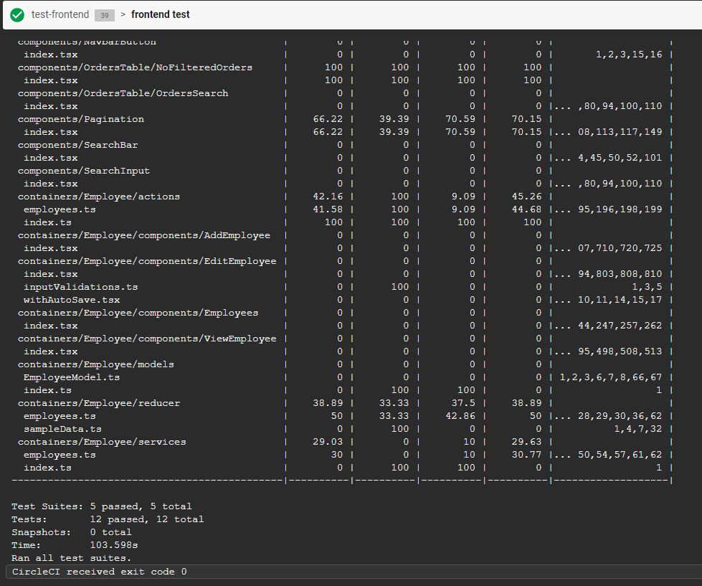

Screen #9 – frontend unit test successful

Screen #9 – backend unit test successful

1. **Analyze Phase – checking for known vulnerabilities**

Screen #10 – jobs that failed because of vulnerability packages listed

Screen #11 – frontend scan

Screen #12 – fixed vulnerability in backend scan

1. **Alerts**

**Section 3: Utilize a Configuration Management Tool to Accomplish Deployment to Cloud Services**

Screen #14: Create/Deploy infrastructure job failure

Screen #15 – Create/Deploy infrastructure job failure